EE 592

PROJECT REPORT

Communication System Final Project

**Linear and adaptive delta modulation**

Project Team Member: Lin Zeng and Harsh Dubey

Date Submitted: May 2, 2019

Professor: Dr. Songxin Tan

Introduction

From the research paper, Pulse Code Modulation (PCM), Delta Modulation (DM), and Adaptive Delta Modulation (ADM) were introduced and compared for its overload and granular/threshold noise. To emulate the result for this project, MATLAB Simulink model for PCM, DM, ADM were built and analyzed by inputting the same signal to each modulator and observing the output pulse coded wave.

Background

In analog to digital signal communication, PCM is the most basic form of digital pulses. It can be achieved by sampling the continuous time signal into discrete sequence and then use a n-level quantizer to characterize the signal sequence. After quantization step, the signal is passed into an encoder for line coding. Binary encoder is popular for its advantages among simplicity, noise rejection ability, and being further used for line coding. Line coding technique such as unipolar and unipolar encoding helps to reduce on the signals’ DC component, overlapping error, or inter-symbol interference, etc.

However, because of the quantizer has a fixed gain and maximum threshold value, and the input signal is usually nonstationary, the quantization noise in PCM has two forms: Overload noise and Granular/Threshold noise.[1] Thresholding error occurs when the amplitude variation of input signal is smaller than the step size, this can be improved by decreasing the step value, but the overload noise is going to be increased. Overload noise occurs when the input signal amplitude exceeds the maximum level of the quantizer step size which results error while tracking the signal. Therefore, PCM has only a small range of optimum performance based on the quantizer step size.

Delta Modulation is the simplest form of PCM which only the difference between two consecutive samples were transmitted. DM also needs oversampled frequency to increase the sample correlation. In DM, the transmitted data are 1-bit data stream and the analog signal is approximated with a series of segments.[2] The basic linear DM system, Fig. 1, has a two-level quantizer and a integrator used for feedback.[1] The quantizer converts the difference between the input signal and the previous segment from the integrator, whose output is 1 or 0 based on the difference. In this way, the redundancy of the signal is considered, and the peak amplitude of the output is much smaller. Therefore, DM would have better signal-to-noise ratio (SNR) and less data are needed to be transmitted. But the modulated signal still suffices overload and threshold noise. To eliminate the overload noise, Adaptive Delta Modulation can be implemented to permit the system self-regulating to optimum performance over a broad range of input signal variation.

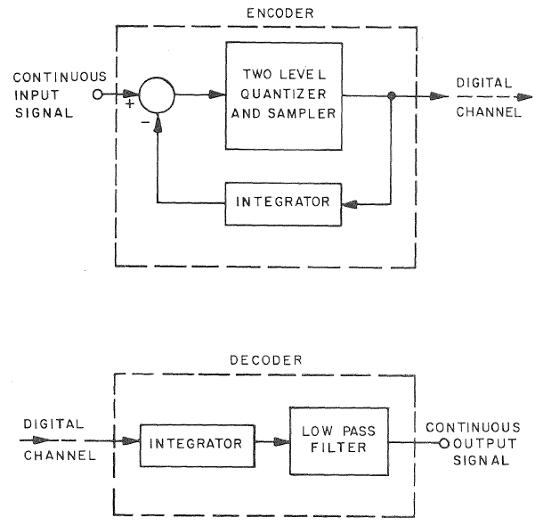

Figure 1: Delta Modulation digital transmission system

Because a lot of stochastic communication signals are nonstationary such as TV and audio signals, Adaptive Delta Modulation is more suited for its capability of encoding nonstationary signals. For a stationary signal, the linear DM system has already been optimally loaded when the sampling frequency is selected to be optimum. Therefore, a linear DM with a gain scheduling network, Fig. 2, by amplifying the step size of the quantizer according to the difference and input amplitude forms the ADM system. Therefore, ADM is expected to have wider range of optimum performance for its SNR compare to PCM and linear DM.

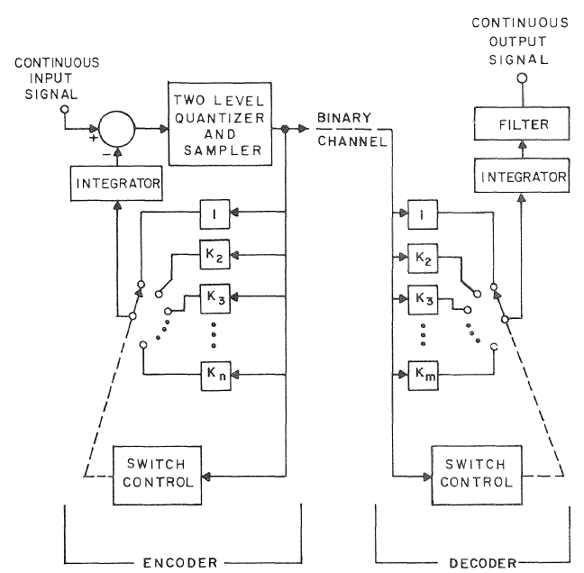

Figure 2: Adaptive Delta Modulation digital transmission system

Procedure

The procedure section of the report is broken into two parts: PCM performance characterization and DM & ADM performance characterization

1. **PCM performance characterization**

By following the basic block diagram of PCM digital signal transmission, Fig. 3, the PCM was built in MATLAB Simulink.

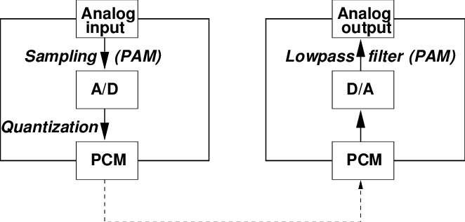

Figure 3: PCM digital transmission system

The PCM Simulink block diagram, Fig. 4, was built with a Sampler, Quantizer, Encoder, Decoder and Low-pass reconstruction filter. MER (Modulated Error Ratio) measurement was used to perform SNR between Input and Quantized signal. [3]

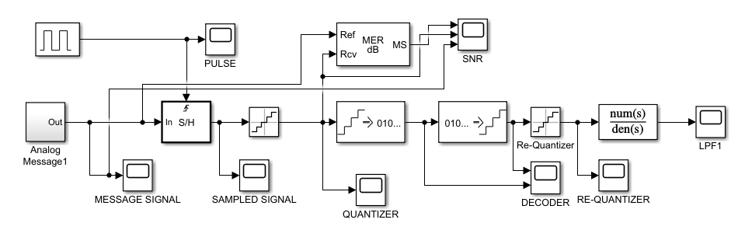

Figure 4: PCM Simulink block diagram

Both a sine wave, Fig. 5, and a non-stationary signal wave, Fig. 6, were each used for the PCM performance analysis.

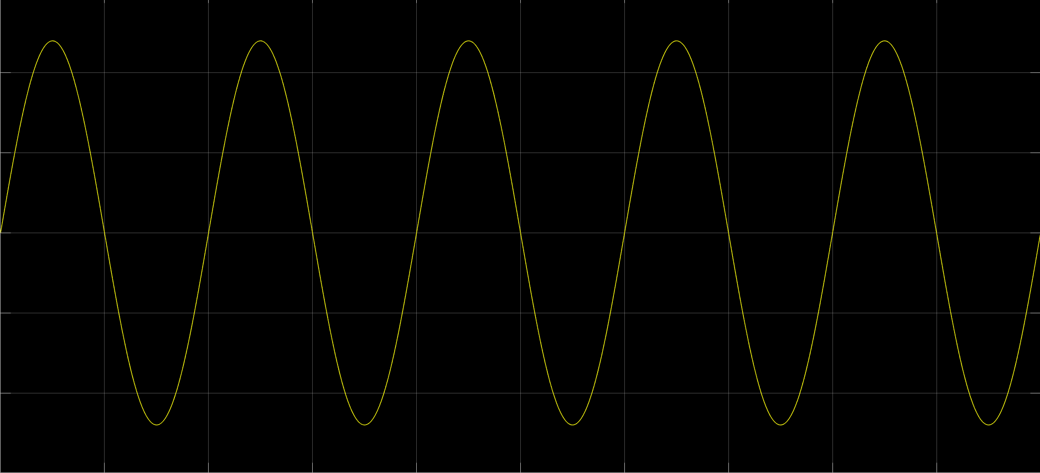

Figure 5: Input stationary sine wave

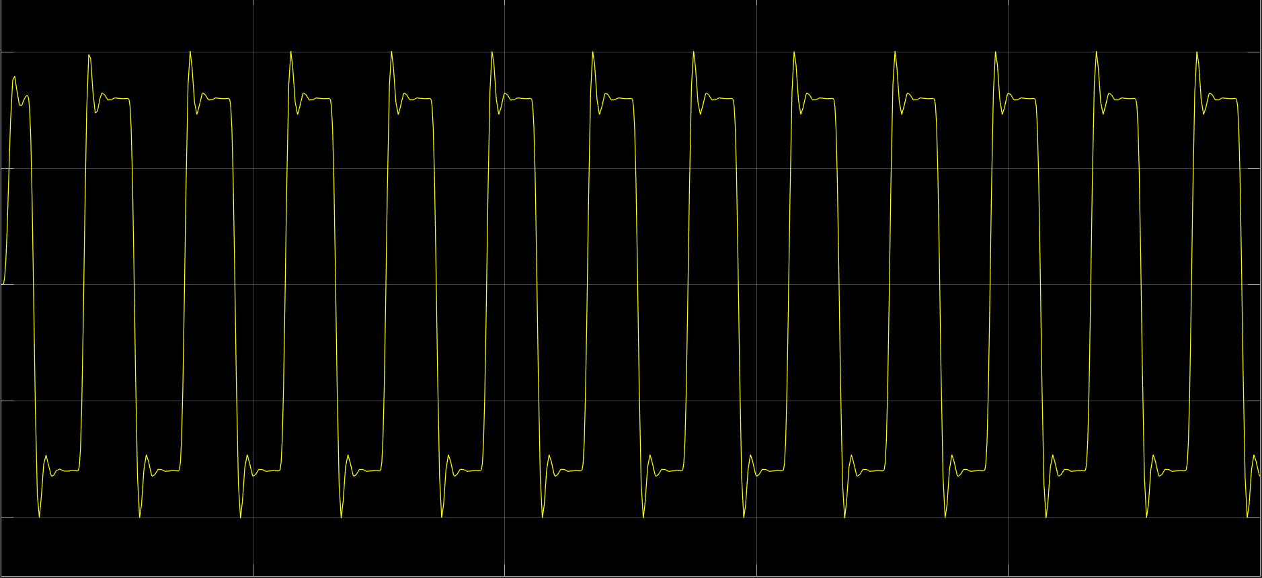

Figure 6: Input non-stationary wave

Table 1 displays the parameters used for the system.

Table 1: PCM component parameters

|  |  |  |  |  |
| --- | --- | --- | --- | --- |
| Input signal frequency (Sine wave) | Sampler Frequency | Sample / Hold circuit trigger | Quantization level | Encoded Bits |
| 10 Hz | 100 Hz | Rising edge | 256 | 8 bits |

1. **DM and ADM performance characterization**

The DM Simulink block diagram, Fig. 7, was built with the availability of MATLAB built-in Model for Delta Modulation. [4]

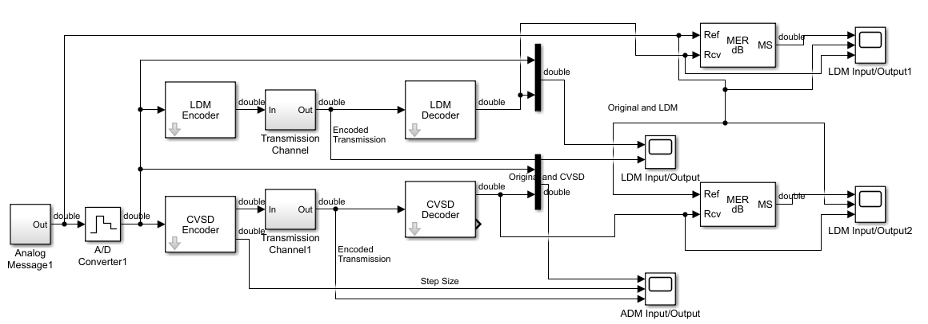

Figure 7: DM (top) and ADM (bottom) Simulink block diagram

The encoder and decoder were used to quantize the sampled signal and encoded into bipolar signal. The non-stationary signal was used for input and was analyzed in both DM and ADM.

Table 2 displays the parameter used for the system.

Table 2: DM/ADM component parameters

|  |  |  |  |  |
| --- | --- | --- | --- | --- |
| Input signal frequency (Sine wave) | Sampler Frequency | Reconstruction integrator time constant | ADM maximum quantization step | ADM minimum quantization step |
| 10 Hz | 8000 Hz | 0.96 | 20 | 0.01 |

The SNR of the delta modulation was then compared with the SNR of the adaptive delta modulation.

Results and Analysis

This section of the report is broken into the same parts as for procedure.

1. **PCM performance characterization**

By mixing the sampling pulse with the input signal, Fig. 8, the analog signal was converted into digital samples.

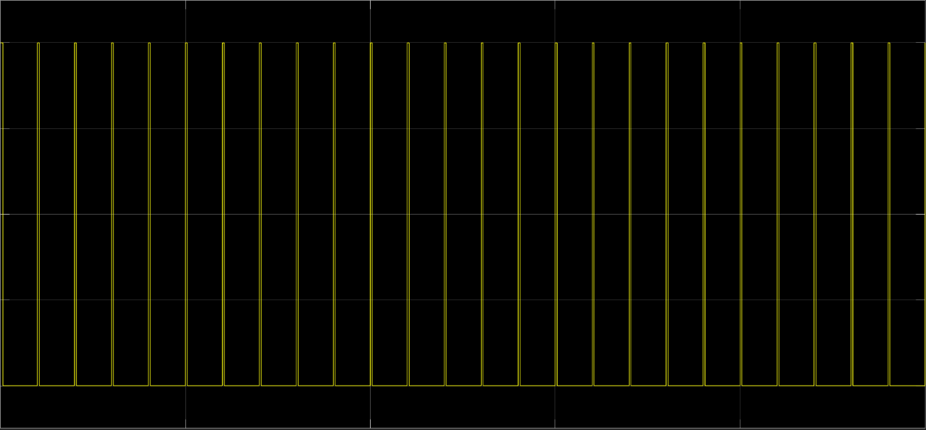

Figure 8: Sampling pulse at 100 Hz

After quantization, the quantized output of PCM with a sine wave signal, Fig. 9, was modulated and can be encoded into binary code for transmission.

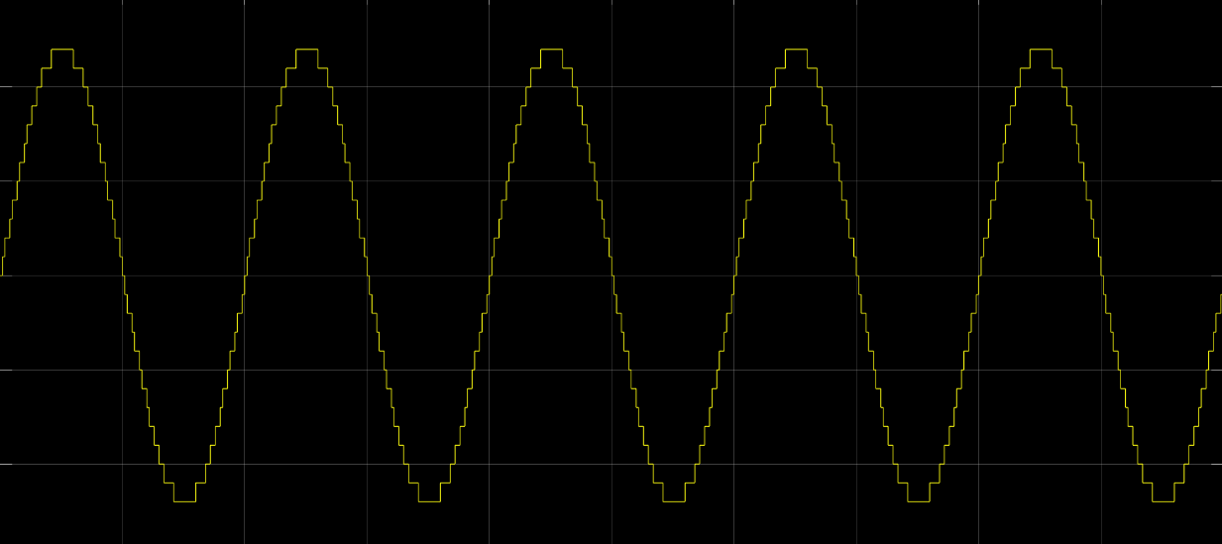

Figure 9: Output of PCM quantized signal with sine wave input

After reconstruction low-pass filter, the reconstructed output signal, Fig. 10, shown the recovery of input signal to the PCM.

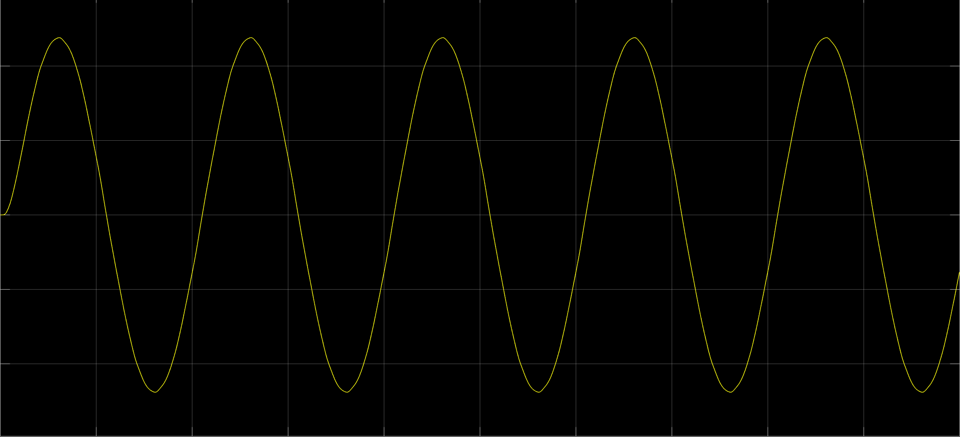

Figure 10: Reconstructed sine wave

The SNR between the input and quantized output signal of the PCM, Fig. 11, shown the overloading noise performance of the PCM under stationary signal.

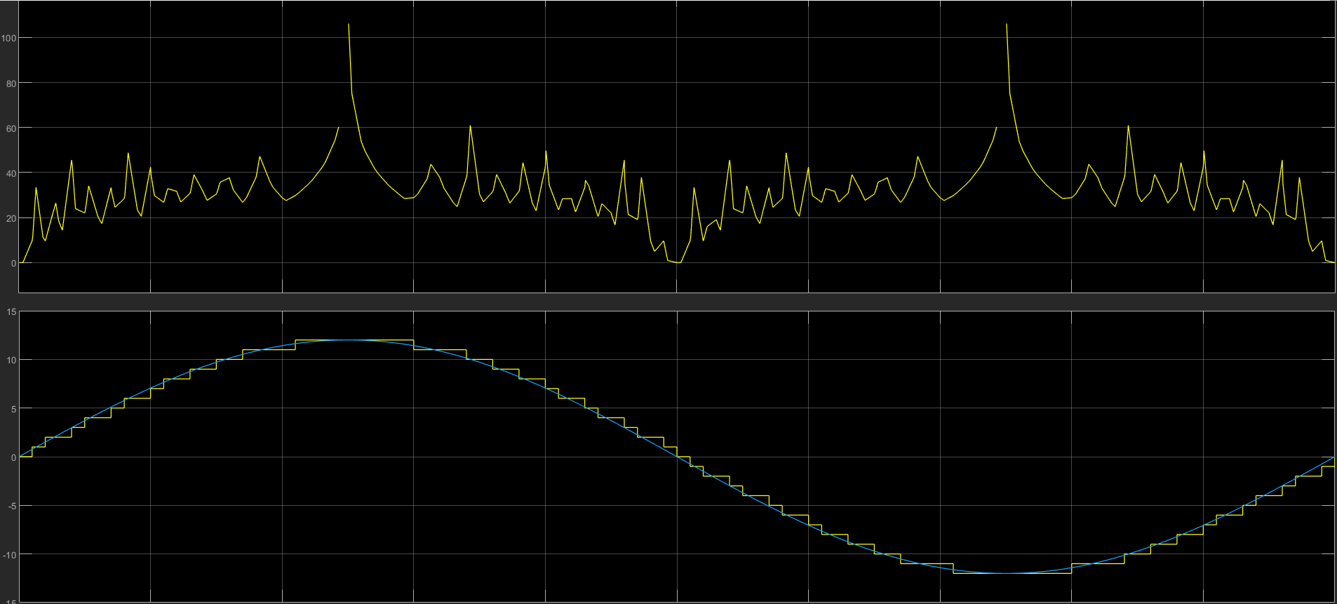

Figure 11: Top, Signal to Noise Ratio (SNR); Bottom, Input (Blue) and Quantized Output (Yellow)

Higher SNR indicates less noise occurs at the point of measurement. Because of the amplitude at the peak of the sine wave stayed constant, the quantizer also stayed constant where the maximum SNR was located at the point of intersection.

The SNR between the input and quantized output signal of the PCM, Fig. 12, shown the overloading noise performance of the PCM under non-stationary signal.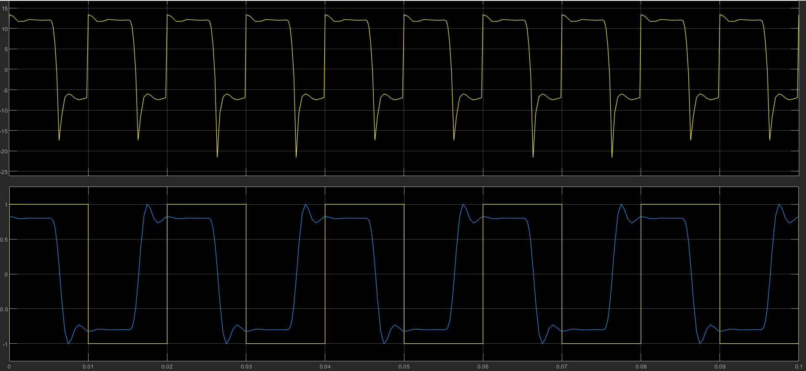

Figure 12: Top, Signal to Noise Ratio (SNR); Bottom, Input (Blue) and Quantized Output (Yellow)

Because of the limited time for this project, sampler frequency was selected low to be able to perform the sine wave modulation. Therefore, the peak value of the non-stationary signal was not tracked by the sampler. Also, there was phase difference between the input and output signal. The highest SNR occurs when there is overlapping between the signal.

1. **DM and ADM performance characterization**

After sampling the input signal, the quantized output and its encoded bipolar binary code, Fig. 13, shown the performance of the DM.

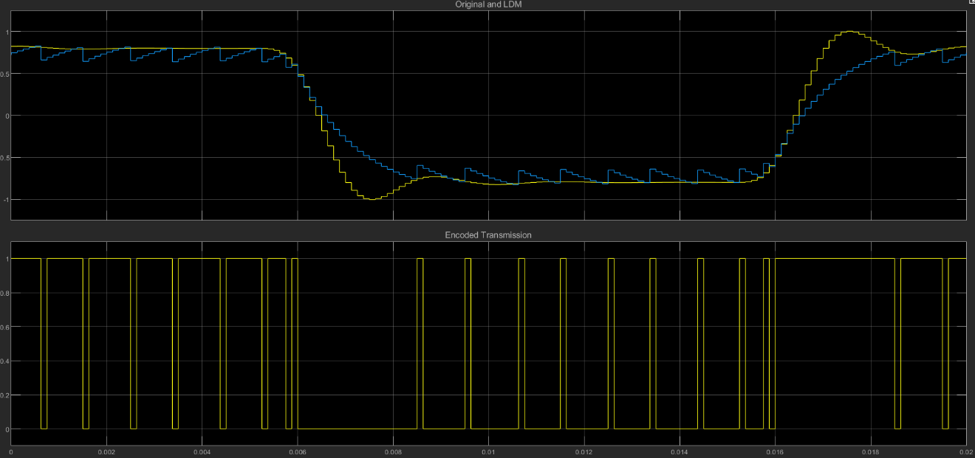

Figure 13: Top, DM sampled Input (Yellow) and quantized output (Blue); Bottom, Encoded output signal

Then with more advantage step size adapting technique, the ADM output result, Fig. 14, shown improved performance compare to DM.

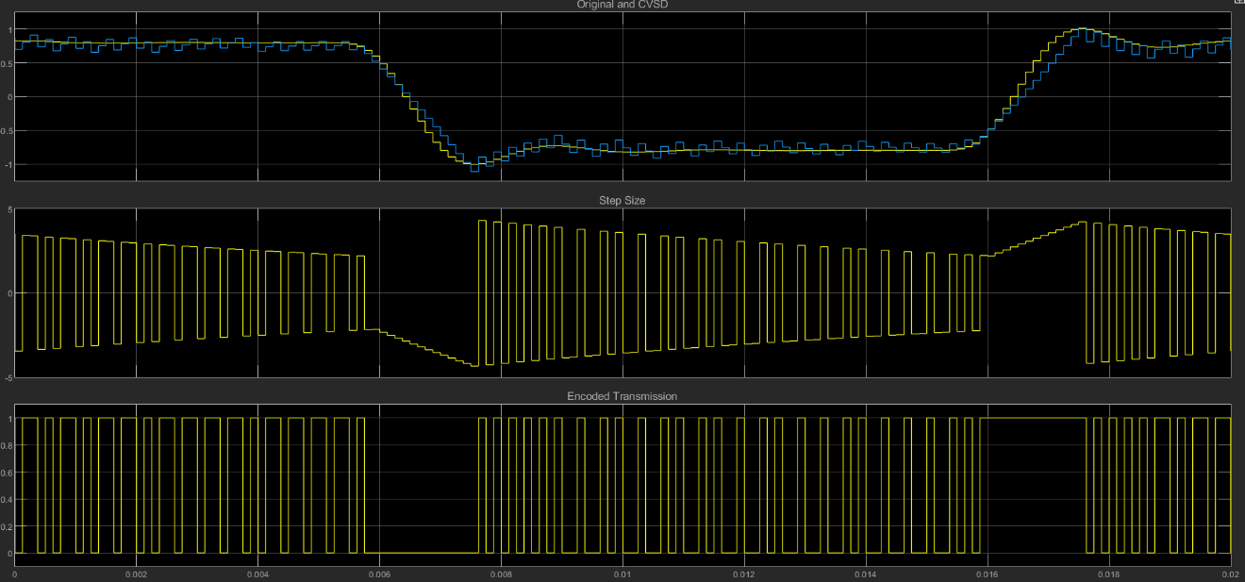

Figure 14: Top, ADM sampled Input (Yellow) and quantized output (Blue); Middle, Step Size; Bottom, Encoded output signal

By looking close to both DM and ADM result, Fig. 15, its overloading noise had been improved for its quantization slope being adapted.

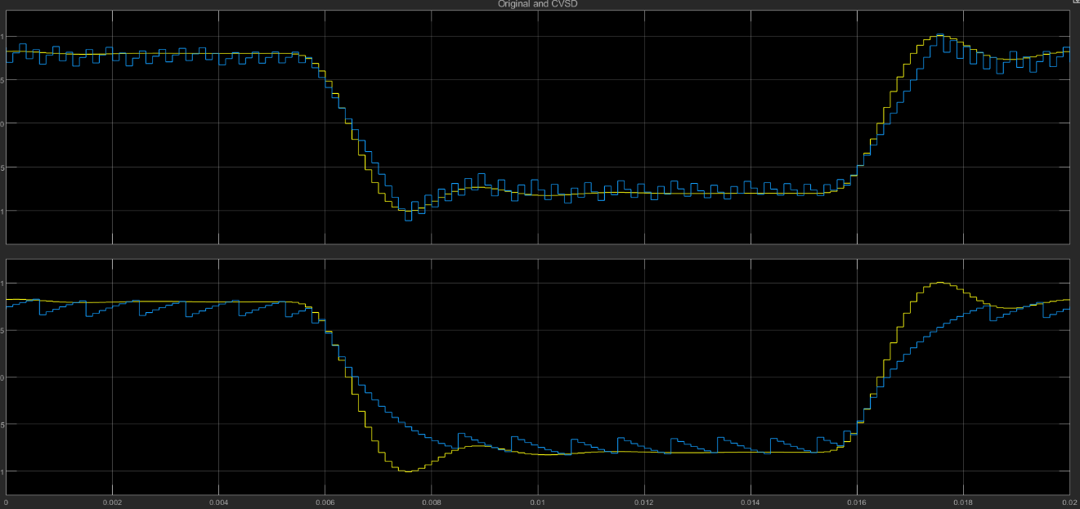

Figure 15: Top, ADM input (Yellow)/output (Blue); Bottom, DM input (Yellow)/output (Blue)

Within the same time period in red marked region, ADM’s step size was increase by one step every time there was a repeated “1” or “0”. Therefore, ADM’s overloading noise was decreased compare to DM fixed step size technique.

The SNR of the DM, Fig. 16, was obtained by measuring the ratio between Input and Output PSD.

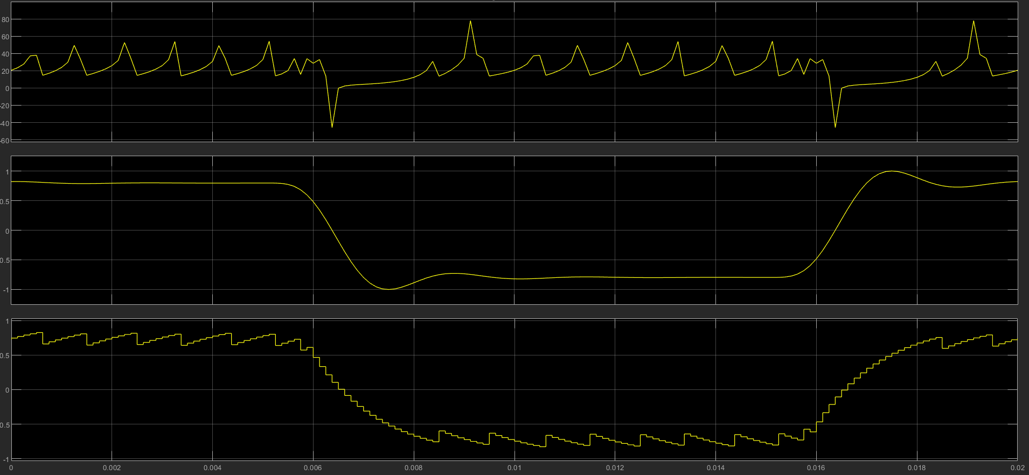

Figure 16: Top, DM SNR between input and output; Middle, DM Input signal; Bottom, DM output signal

The SNR of the ADM, Fig. 17, was obtained by measuring the ratio between Input and Output PSD.

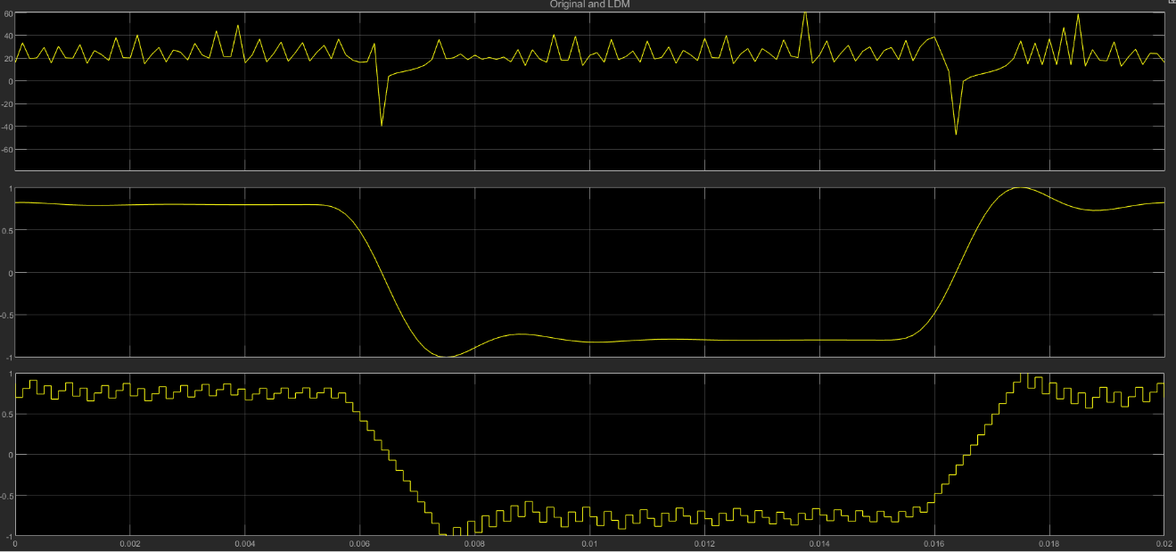

Figure 17: Top, ADM SNR between input and output; Middle, ADM Input signal; Bottom, ADM output signal

By looking at steep slope changing time period marked in red for both DM and ADM. ADM had better SNR performance than DM because ADM’s SNR increased faster than that of DM in the same time period.

Conclusion

Pulse Coded Modulation quantizes the amplitude of the input signal with 2n quantization level to be encoded for digital transmission. Delta Modulation only have two-level of quantization (Positive or Negative) based off the difference of present value and previous value. In this way, less data needs to be sent with better signal-to-noise ratio. Adaptive Delta Modulation can be used to further decrease the overloading error in Delta by actively increase the step size of the quantizer.

References

1. J. Abate, "Linear and adaptive delta modulation", *Proceedings of the IEEE*, vol. 55, no. 3, pp. 298-308, 1967. Available: 10.1109/proc.1967.5486 [Accessed 28- April- 2019].
2. "Delta modulation", En.wikipedia.org, 2019. [Online]. Available: https://en.wikipedia.org/wiki/Delta_modulation. [Accessed: 28- April- 2019].
3. "EVM and MER Measurements with Simulink- MATLAB & Simulink", Mathworks.com, 2019. [Online]. Available: https://www.mathworks.com/help/comm/gs/evm-and-mer-measurements-with-simulink.html. [Accessed: 29- April- 2019].
4. "Comparison of LDM, CVSD, and ADPCM- MATLAB & Simulink", Mathworks.com, 2019. [Online]. Available: https://www.mathworks.com/help/dsp/examples/comparison-of-ldm-cvsd-and-adpcm.html. [Accessed: 29- April- 2019].